North of England Packaging Society (NEPKGS)
Constitution – adopted October 2020
- NEPKGS exists in order to provide networking and continuing professional development for packaging professionals living and/or working in the North of England, at every stage of their career and people simply interested in the packaging industry.

- For the sake of this document a packaging professional is anyone that works within the packaging industry, this could be a packaging technologist, artwork co-ordinator, printer, machine operator etc.

- A list of members is kept by a designated member of the committee. Members are i) Those that have signed up to the electronic newsletter or ii) are a member of IOM3 and iii) live or work in the North of England and iv) have attended at least one meeting, in person or virtually in the year up to the AGM.

- NEPKGS is affiliated to IOM3 as a local society.

- Officers. There shall be a committee of at least two officers, elected annually at the AGM. The following tasks will be divided between them;

- Chair – Co-ordination of the group, liaison with IOM3, co-signatory of bank account.
- Vice / Co-chair
- Treasurer – accounts and co-signatory of bank account.
- Secretary – minute taking and timely issuing thereof (within 2 weeks)
- Events organisers – talks, visits etc.
- Social Media
- Newsletter
- Membership development

Plus any other tasks seen as desirable for the running of the society.
Because of their nature i) to iii) to be held by a single individual for each role for the entire year, iii) onwards can be shared tasks, again for the period of one year.
- Dissolution of the society
Should there not be enough interest in the continuation of the group, and after a reasonable attempt has been made to consult the members and find committee officers, the remaining officers i.e. the bank account signatories will declare the society dissolved, close the bank account and pay any remaining balance to IOM3, ideally for the members benevolent fund.

Adopted: October 2020
Signed:
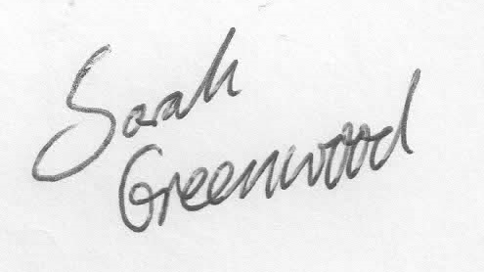
28/11/20

